Course Outcomes

CO-1 | Interpret the functional architecture of operating systems. (Understanding)  - Classify and study various OS implementation techniques.  - Understand how to implement system calls.  - Relate to fundamentals for file system implementation.  - Understand the basics of paging and segmentation and study advanced combination schemes based on them.  - Learn about various I/O devices and the I/O function.  - Appreciate process management functions like user/kernel level threads, multithreading, deadlock and process synchronization.  - List down the issues and ways to enforce system protection and security.
CO-2 | Identify, compare and assess issues related to process management, file systems and memory management. (Applying, Analyzing, Evaluating)  - Estimate the performance of various memory management techniques.  - Compare page replacement techniques.  - Analyze deadlock situations and suggest remedies.  - Evaluate advanced implementations like LFS and optimization for file system performance.
CO-3 | Design and analyze solutions in the area of operating systems. (Analyzing, Creating)  - Solve synchronization problems using synchronization tools like semaphores, monitors etc.  - Ability to add system calls to an OS.  - Ability to write multithreaded code.

Assessment of Attainment of Course Outcomes
Assessment Type | Course Outcome
 | CO-1 | CO-2 | CO-3
Final Exam | 40% | 30% | 30%
Assignments | 40% | 30% | 30%
Mid Sem Exams | 40% | 30% | 30%

Question Paper to CO mapping
Sessional 1 |  |  |  | Sessional 2 |  |  |  | End Semester
Q.No. | CO-1 | CO-2 | CO-3 | Q.No. | CO-1 | CO-2 | CO-3 | Q.No. | CO-1 | CO-2 | CO-3
1 | √ |  |  | 1 | √ |  |  | 1 | √
2 |  | √ |  | 2 |  |  |  | 2 | √
3 | √ |  |  | 3 |  |  |  | 3 |  | √
 |  |  |  |  |  |  |  | 4 |  | √ | √

UAD | MMD | ASM
Moderation Committee

End Semester Examination Winter 2017

Branch: 5th Sem, B.Tech. CSE Course: Operating Systems (CSL309)
Duration: 3 hours Max. Marks: 50

Note: Attempt subparts of a question together. State clearly any assumptions used for answering.

 |  | Answer the following with respect to memory management | 10
 |  | Base-limit MMUs can support swapping. What is swapping? Can swapping permit an application requiring 16M memory to run on a machine with 8M of RAM?
 |  | Describe the difference between external and internal fragmentation. Indicate which of the two are most likely to be an issue on (i) a simple memory management machine using base limit registers and static partitioning, and (ii) a similar machine using dynamic partitioning.
 |  | Consider a memory system with a cache access time of 10ns and a memory access time of 200ns. If the effective access time is 10% greater than the cache access time, what is the hit ratio?
 |  | Assuming a page size of 1 KB and that each page table entry takes 4 bytes, how many levels of page table will be required to map a 34-bit address if every page table fits into a single page. Draw a neat diagram to show how the address translation happens for this paging scheme.
 |  | Answer the following with respect to file systems | 10
 |  | What is the reference count field in the inode?
 |  | Why might the direct blocks be stored in the inode itself?
 |  | What is the maximum file size supported by a file system with 16 direct blocks, single, double, and triple indirection? The block size is 512 bytes. Disk block numbers can be stored in 4 bytes.
 |  | Given that the maximum file size of combination of direct, single indirection, double indirection, and triple indirection in an inode-based filesystem is approximately the same as a filesystem solely using triple indirection, why not simply use only triple indirection to locate all file blocks?
What are all kinds of file system consistency checks which fsck or a similar file system checker makes to protect a user against crashes? Illustrate the algorithms for the checks in detail.
Can you think of a file system feature that protects the user against (an accidental action by) himself.
 |  |  | 10
For each of the following page replacement policies, list the total number of page faults and fill in the contents of the page frames of memory after each memory reference. Draw and populate a table like the one shown below for each case of (i) Optimal (ii) LRU and (iii) FIFO. Assume memory to be empty initially for each case.
Reference | E | D | H | B | D | E | D | A | E | B | E | D | E | B | G
Frame 1
Frame 2
Frame 3
Mark P
for a fault

A system has five processes and four allocatable resource types. The current allocations and maximum needs are as given below. The resource types are available in the following amounts: R = (2, 1, 2, 0) at this snapshot.

Current Allocations |  |  |  |  |  |  | Maximum Needs
 | R₁ | R₂ | R₃ | R₄ |  |  |  |  | R₁ | R₂ | R₃ | R₄
P₁ | 0 | 0 | 1 | 2 |  |  |  | P₁ | 0 | 0 | 3 | 2
P₂ | 2 | 0 | 0 | 0 |  |  |  | P₂ | 2 | 7 | 5 | 0
P₃ | 0 | 0 | 3 | 4 |  |  |  | P₃ | 6 | 6 | 5 | 6
P₄ | 2 | 3 | 5 | 4 |  |  |  | P₄ | 4 | 3 | 5 | 6
P₅ | 0 | 3 | 3 | 2 |  |  |  | P₅ | 0 | 6 | 5 | 2
- Write the pseudo-code for Banker’s algorithm, with a provision to record the safe sequence as well.
- Is this system currently deadlocked? Why or why not? If not deadlocked, then give a safe sequence.
- If P₁ requests for (0, 4, 2, 0), can the request be immediately granted? Why or why not? If yes, then show an execution order.
- If P₂ requests for (0, 1, 2, 0), can the request be immediately granted? Why or why not? If yes, then show an execution order.

 |  | Answer the following with respect to process management | 20
 |  | Contrast in a tabular fashion between user-level threads and kernel-level threads.
Consider the following producer and consumer functions using semaphores
void producer (item)  {  down(mutex);  down(holes);  insert_item(item, buffer);  up(items);  up(mutex);  } | item consume()  {  down(mutex);  down(items);  item=remove_item(buffer);  up(holes);  up(mutex);  }
- Try to identify the shared data, their types and initializations with proper assumptions for a buffer of size N.
- Prove/disprove if the above code is correct by evaluating all possible execution sequences and if the code is not correct, identify the problem and correct it too.

[Advice: Please try to attempt this question towards the end of the exam]
Consider global variables x and y initialized to a and b respectively. Each of the cases below is to be considered independently, i.e. the initial values of x and y is a and b respectively for each case. For each case below, identify and show the interleaving of instructions which produces the final values calculated for x and y.

- If two threads execute foo() concurrently, what are all the possible values of ‘x’ and ‘y’.
void foo(void) {
x=x+1;
y=x+y; }
- Now consider the function with locking using a global lock (which has been properly initialized). If two threads execute foo_lock1() concurrently, what are all the possible values of ‘x’ and ‘y’.
void foo_lock1(void) {
tset(&lock);
x=x+1;
y=x+y;
lock=false; }
- Now consider the function with locking using two global locks (which have been properly initialized). If two threads execute foo_lock2() concurrently, what are all the possible values of ‘x’ and ‘y’.
void foo_lock2(void) {
tset(&lock1);
x=x+1;
lock1=false;
tset(&lock2);
y=x+y;
lock2=false; }
- Now consider the function with locking using two global locks (which have been properly initialized). If two threads execute foo_lock3() concurrently, what are all the possible values of ‘x’ and ‘y’.
void foo_lock3(void) {
tset(&lock1);
x=x+1;
tset(&lock2);
y=x+y;
lock1=false;
lock2=false; }

Solutions
1.
a.
Swapping is the act of running each whole process in main memory for a time then placing back onto disk and vice versa. It is used when the system does not have enough main memory to hold all the currently active processes.
Assuming that an application is one program and hence a single process, swapping will not permit an application(process) requiring 16M of memory to run on a machine with 8M RAM (main memory) as the whole process is too large to fit into main memory.

b.
- Internal fragmentation: the space wasted internal to the allocated region.Allocated memory might be slightly larger than requested memory.
- External fragmentation: the space wasted external to the allocated region.memory exists to satisfy a reqest but it's unsuable as it's not contiguous.
Stattic partitioning is more likely to suffer from internal fragmentation.
Dynamic partitioning is more likely to suffer from external fragmentation.

c.

d.

2.
a.
The refernce count is the number of hard links (names in directories) presently pointing at a particular inode. When this reaches zero, it is an indication that that inode can be deleted, since nothing points at it anymore (it has no name).

b.
Quick access to the start of the file stored in the inode itself. For small files, no direct blocks required, entire file can be in the inode. This improves the performance for small files.

c.
block size = 512
number of block numbers in an indirection block
= block size / 4
= 128
number of blocks for file data in that file object
= 16 + 128 + 128^2 + 128^3
Maximum file size:
(direct + single indirect + double indirect + triple indirect) * (blocksize)
= (16 + 512/4 + (512/4)^2 + (512/4)^3) * (512)
= 68853964800 bytes, ~64 gigs

d.
Triple indirection is slower, as it may result in multiple seeks to get to the desired block. Seeks take a long time. Tiny files that only use a few KB will perform much better if they do not have to do seeks to find each level of indirection

e.
block level, file level etc.

3.
a.

b.

4.
a.
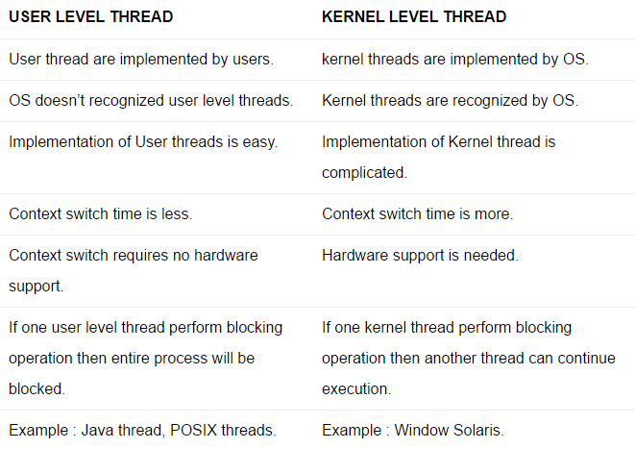

b.
Shared Data:
item buffer[N]; semaphore mutex=1, holes=N, items=0;

Problem is deadlock, mutex should only protect the buffer.

c.

Case | x | y | Interleaving
1 | a + 2  a + 1  a + 2  a + 2  a + 2  a + 2  a + 2 | b + 2 a + 3  b + 2 a + 2  b + 2 a + 4  b + 2 a + 3  b + a + 1  b + 2 a + 3  b + 2 a + 3 | RaWaRaRbWb; RaWaRaRbWb  Ra; RaWaRaRbWb; WaRaRbWb  RaWa; RaWaRaRbWb; RaRbWb  RaWaRa; RaWaRaRbWb; RbWb  RaWaRaRb; RaWaRaRbWb; Wb  RaWaRa; RaWaRaRbWb; RbWb  Ra; RaWaRaRbWb; WaRaRbWb  Ra; RaWaRaRbWb; WaRaRbWb | 1  2  3  4  5  6  7  8  9  10  11  12  13
2 | a + 2 | b + 2 a + 3 | ABAB
3 | a + 2 | b + 2 a + 3  b + 2 a + 4 | ABAB  AABB
4 | a + 2 | b + 2 a + 3 | ABAB

(a + 1, a + 2) X (b + a + 1, b + a + 2, b + 2a + 1, b + 2a + 2, b + 2a + 3, b + 2a + 4)

Backup

 |  | Consider the following processes with given arrival times and times to completion. For each of the cases below draw a Gantt Chart, calculate total turnaround time and a Table having columns (Process ID, Arrival, Start, Finish, Turnaround time) for each process.  Process ID Arrival Length  P1 0 3  P2 1 6  P3 2 2  P4 6 3  P5 10 1  Compute the turnaround time for each process if using (non-preemptive) Shortest Job First, breaking ties in favor of the process that arrived earliest.  Find a non-preemptive schedule that minimized total turnaround time for the above set of processes. The CPU may be idle for portions of your schedule.  Compute the turnaround time for each process if using Shortest Remaining Time First where jobs can be preempted when other jobs arrive. This time, break ties in favor of the process that arrived latest. | 5

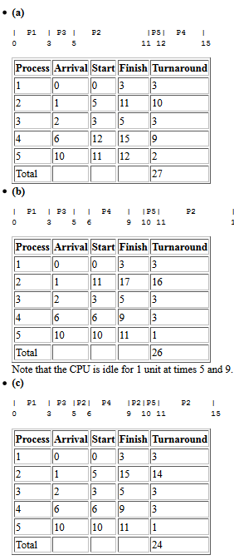

synch mem process io file

How does an OS detect Thrashing?. How does it deal with it?

Is it possible for the CPU utilization of your system to be 100% if all the threads in the
system are involved in a deadlock? Explain.

Thrashing can be detected by measuring the page fault frequency. A high page fault frequency
(due to swapping) implies thrashing. It can be avoided through better scheduling. For example, a
set of processes whose working set is likely to fit in the available RAM is run together for an
extended time (say 1­5 seconds), and then swapped out together to allow another group of
processes to get swapped in. This reduces the rate of page faults, and ensures faster overall progress.
Yes
​
, It is possible for system to have a 100% CPU utilization even in the case of
deadlock. Consider the case when the threads involved in the system use
​
spin locks,
​
now
if the threads are even in a deadlock scenario they will constantly check for reacquiring the
lock whenever they get a chance to run hence consuming the cpu constantly which can result
in 100% CPU utilization.

Derivation for interleaving of instructions: n-processes, m-instructions in each thread
